1. Add:
2. Resumed
3. Resumed
4. onResume

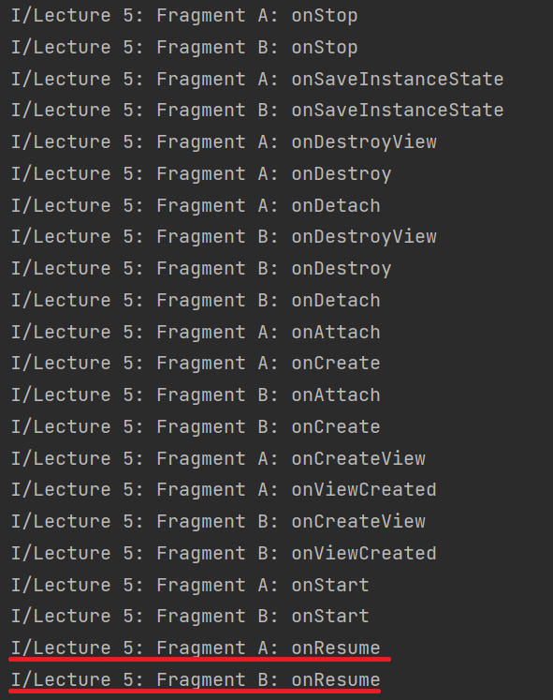

1. Replace:
2. FragmentA – Destroyed, FragmentB – Resumed
3. FragmentA – Destroyed, FragmentB – Resumed
4. FragmentA – onDetach, FragmentB – onResume

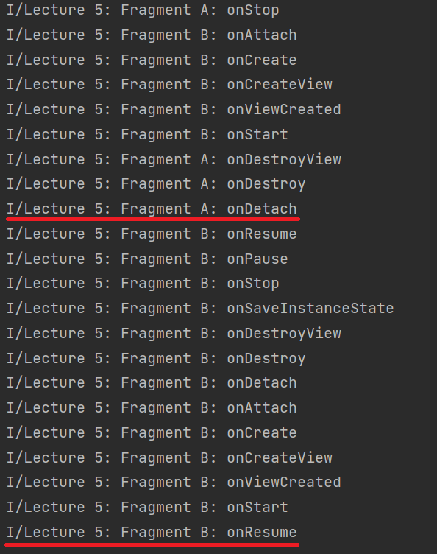

1. Add + addToBackStack:

1. Resumed

2. Resumed

3. onResume

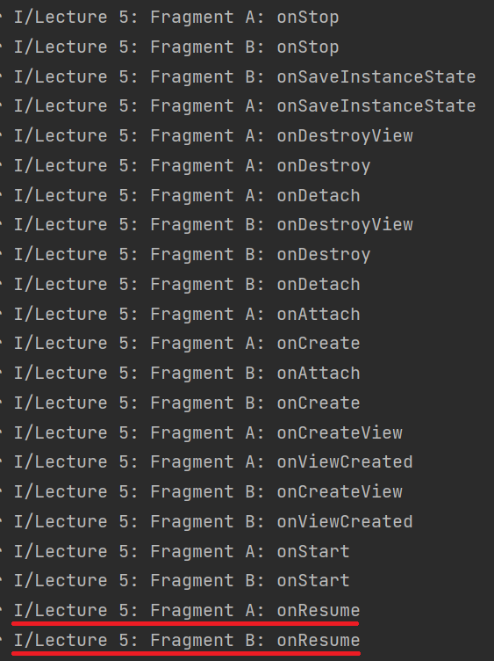

1. Replace + addToBackStack:
2. FragmentA – Created, FragmentB – Resumed
3. FragmentA – Created, FragmentB – Resumed
4. FragmentA – onCreate, FragmentB – onResume

